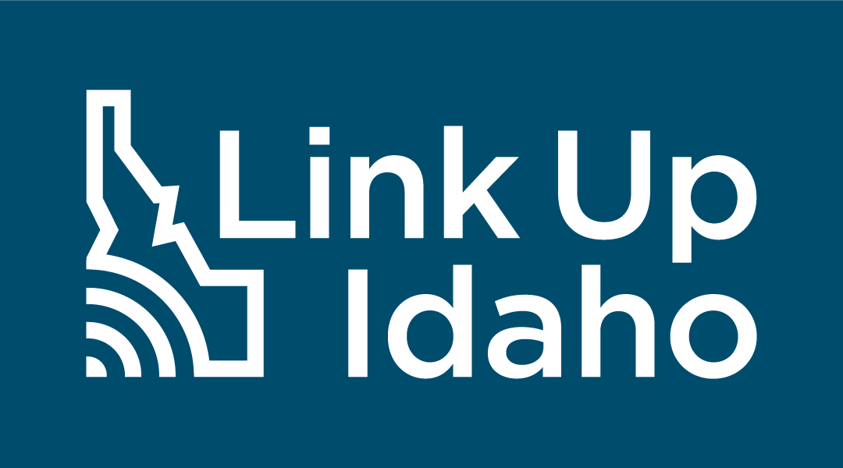

Communications Toolkit
Public Comment Period
Sept. 29 – Oct. 31, 2023

Target Audience: All Idaho citizens and small business owners

Goal: Statewide participation in the Public Comment Period for Vol. I & Vol. II of the BEAD Initial Proposal

https://linkup.idaho.gov

About Link Up Idaho
The Link Up Idaho initiative is led by the Idaho Broadband Advisory Board (IBAB) and the Idaho Department of Commerce, in coordination with the Idaho Office of Information Technology Services. This multifaceted initiative aims to gather information about internet connectivity challenges in Idaho communities to provide insight into internet availability across the state, provide outreach across Idaho to inform communities of the availability of broadband funds, and disperse funds to communities to improve internet access. Link Up Idaho’s mission is to provide all Idahoans with access to affordable and reliable broadband infrastructure.
The Idaho Office of Broadband has launched the Link Up Idaho initiative to better understand who has access to high-speed, affordable internet in the state, what areas are struggling to connect and to develop a strategic plan to ensure everyone can access reliable, fast, affordable internet. The State’s robust internet expansion plans are outlined and detailed in the Broadband, Equity, Access, and Deployment Initial Proposal Volumes I and II. The plans are now available for your review and feedback at Linkup.Idaho.gov. Comments will be accepted September 29 – October 31, 2023. To learn more about broadband expansion in Idaho, or to participate in the 30-Day Public Comment Period, visit https://linkup.idaho.gov/.

Logos

Standard
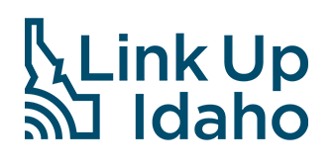
Reverse

Social Media
This toolkit aims to provide helpful resources and materials to encourage participation in the 30-Day Public Comment Period and statewide virtual meeting for the Vol. I and Vol II of the BEAD Initial Proposal, available at https://linkup.idaho.gov/.

How to use Social Media
The prepared text and graphics are ready to be used in social media posts to promote participation in the Idaho Public Comment Period. Please follow these step-by-step instructions on how to post to your social media channels.
- Download the image by right-clicking the image and save it to your desktop. Additionally, you can also find high-quality versions of the images here.
- Log in to the appropriate social media site with your organization’s credentials.
- Copy and paste the corresponding text copy into the post and include the social campaign hashtags as noted below.
- Upload the saved image from your desktop to the post.
- Post the status update.
- Repeat as needed for multiple posts on different social media sites.
- Pin the social media post to the top of your profile page for increased visibility.
If you are unsure how to post to different social media sites, please follow the links below for instructions directly from the social media site.
- Facebook
- Twitter
- Instagram
- LinkedIn

Social Campaign - Hashtags
In all posts, please include the hashtag #LinkUpIdaho. The appropriate secondary hashtag is #IdahoBroadband.

Idaho Department of Commerce’s Facebook, Twitter and LinkedIn accounts will also be posting about the Public Comment Period throughout the 30+ days commenting remains open. We encourage you to tag, re-post, and interact with Link Up Idaho’s posts. Follow us on Facebook, Twitter and LinkedIn: @IdahoCommerce.
Facebook
Twitter
LinkedIn

Social Media Posts

Target: Resident/Community
POST TEXT:

Slow internet? No internet?

Idaho has plans to change that.

The Idaho Office of Broadband has been developing dynamic plans to ensure everyone can access reliable, fast, affordable internet. The State’s robust internet expansion plans are outlined and detailed in the Broadband, Equity, Access, and Deployment Initial Proposal Volumes I and II.
And the plans are now available for your review and feedback at LinkUp.Idaho.gov.
Comments will be accepted September 29 – October 31.
#LinkUpIdaho #IdahoBroadband
Facebook/ Twitter/LinkedIn  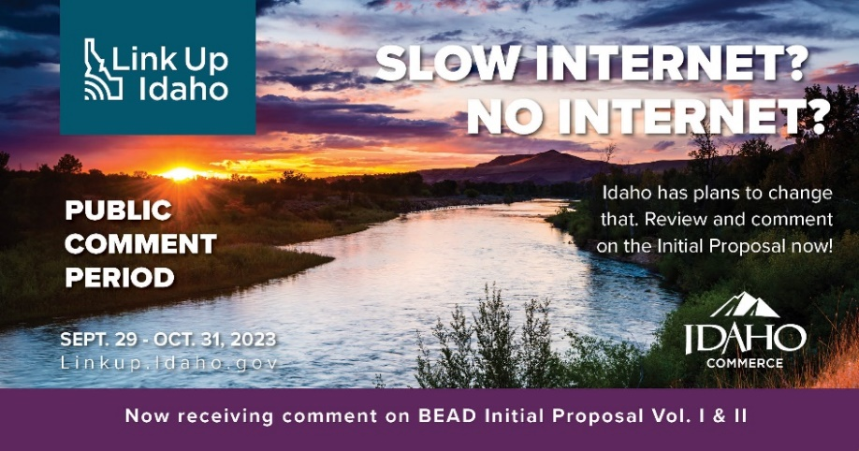 | Instagram  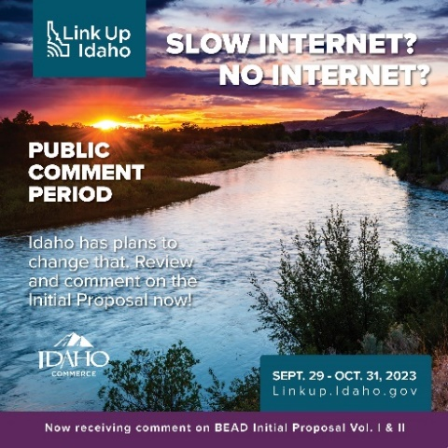

Target: Resident/Community
POST TEXT:

The Idaho Office of Broadband and the Idaho Broadband Advisory Board will be hosting a Virtual Public Comment Period Meeting on October 11, 2023, from 10 a.m. to 12 p.m. MT. Up-to-date information and registration will be available on LinkUp.Idaho.gov. #LinkUpIdaho #IdahoBroadband

Facebook/ Twitter/LinkedIn  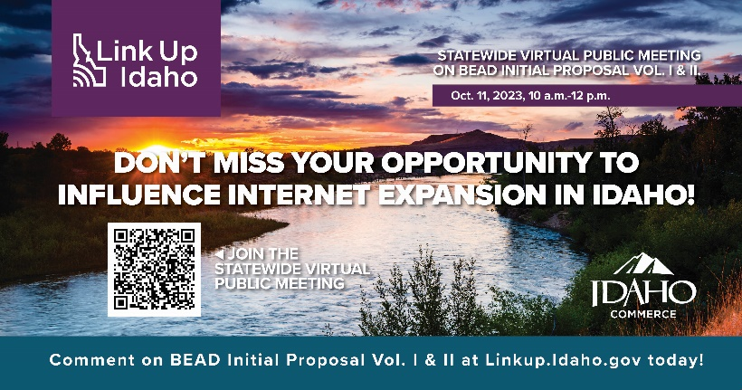 | Instagram  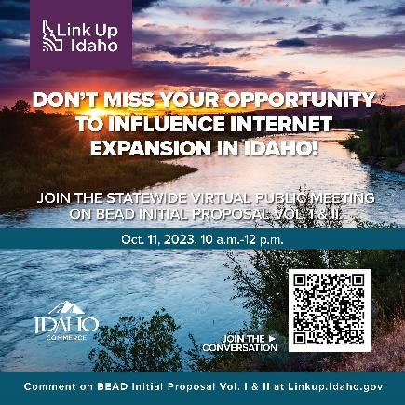

Eblast for Champions
Email Header Graphic:
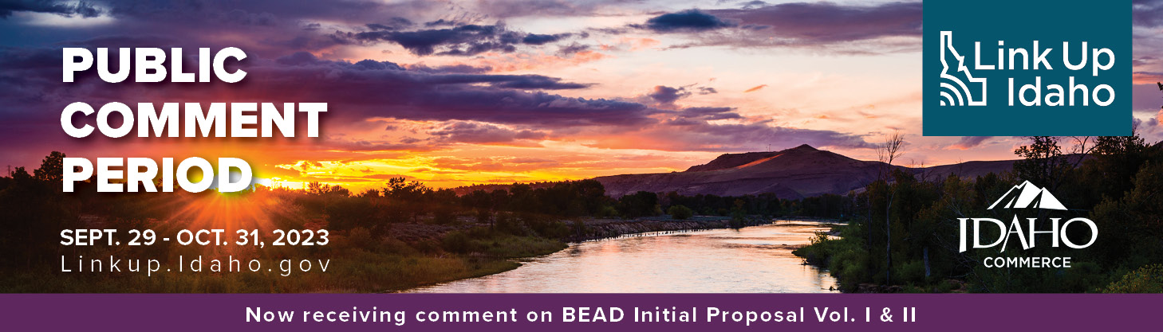

Email Subject: Idaho’s Internet Expansion Plans Now Available for Comment
Email Pre-Header: We Need to Hear From You! Give Your Thoughts About the State’s Internet Expansion Plans Today.
Reliable and affordable high-speed internet is a necessity for everyday life. But the digital divide makes it difficult for many Idahoans to get online and stay online. To better understand the challenges and propose solutions, the State of Idaho has been working to assess the internet service needs and gaps residents, businesses, organizations, and communities face.
The work is reflected in the State’s draft Broadband, Equity, Access, and Deployment (BEAD) Initial Proposal Volume I and Volume II, which you can view by visiting LinkUp.Idaho.gov. Volume I lays the groundwork for the State’s work to bring internet to all. Volume II details the plans for distributing deployment funding, workforce and economic development initiatives, tribal coordination, and more.
The BEAD Initial Proposal Volumes I and II are now posted online at LinkUp.Idaho.gov for your review and feedback. Comments can be submitted to BroadbandComments@Commerce.Idaho.gov and will be accepted from September 29 through October 31.
A Statewide Virtual Public Meeting on Idaho’s BEAD Initial Proposal Vol. I & II will be hosted by the Idaho Office of Broadband on Oct. 11, 2023, from 10 a.m. to 12 p.m. MT. Learn about the plans and provide comments in real time.
Let your voice be heard. Submit comments today!
Know someone who’s interested but doesn’t have internet? No problem. Copies of the BEAD Initial Proposal Volumes I and II, and computers to provide comments, may be available at a library near you.
To learn more about broadband expansion in Idaho or for more on public engagement activities surrounding the effort, visit LinkUp.Idaho.gov.

Newsletter/Article
Idahoans Asked to Provide Feedback on the State’s Internet Expansion Plans
Access to reliable and affordable high-speed internet is necessary to fully participate in our economy and society. Unfortunately, internet access issues affect almost every population and business sector in Idaho. By better understanding who has access to high-speed, affordable internet in the state and what areas are struggling to connect, the State has been able to assess strategies for establishing broadband service in unserved and underserved areas.
The State has been working to identify the State’s internet needs, challenges, and opportunities to develop internet expansion plans. The work is reflected in the State’s draft Broadband, Equity, Access, and Deployment (BEAD) Initial Proposal Volumes I and II. Volume I lays the groundwork for the State’s work to bring internet to all. Volume II details the plans for distributing deployment funding, workforce and economic development initiatives, tribal coordination, and more.
The BEAD Initial Proposal Volumes I and II are now posted online at LinkUp.Idaho.gov for the public to review and provide feedback. The Office of Broadband will accept comments submitted to BroadbandComments@Commerce.Idaho.gov from September 29 through October 31.
Additionally, a Statewide Virtual Public Meeting on Idaho’s BEAD Initial Proposal Vol. I & II will be hosted by the Idaho Office of Broadband and the Idaho Broadband Advisory Board on Oct. 11, 2023. Learn about the plans and provide comments in real time. Visit LinkUp.Idaho.gov to learn more.
For those who don’t have internet but are interested in submitting comments, copies of the BEAD Initial Proposal Volumes I and II, and computers to provide comments, may be available at a library near you.
To learn more about broadband expansion in Idaho or for more on public engagement activities surrounding the effort, visit LinkUp.Idaho.gov.

Block Ads
A block ad can be provided to stakeholders and other partners for use in their newsletters. This is a 4 x 6 size.

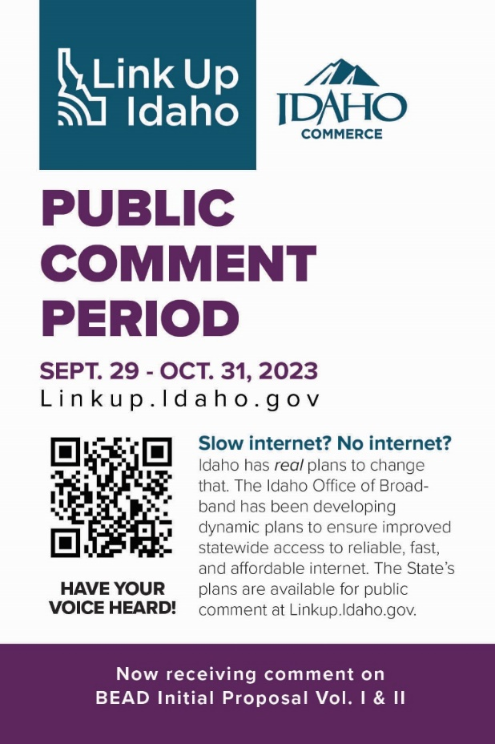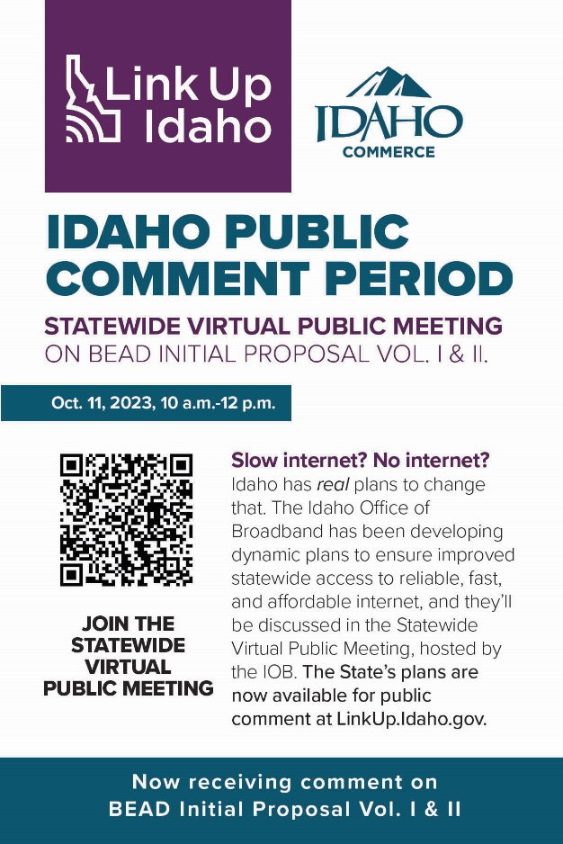

Flyer (Single-sided)
Letter – 8 ½ x 11
Half Page (double sided) – 8 ½ x5 ½
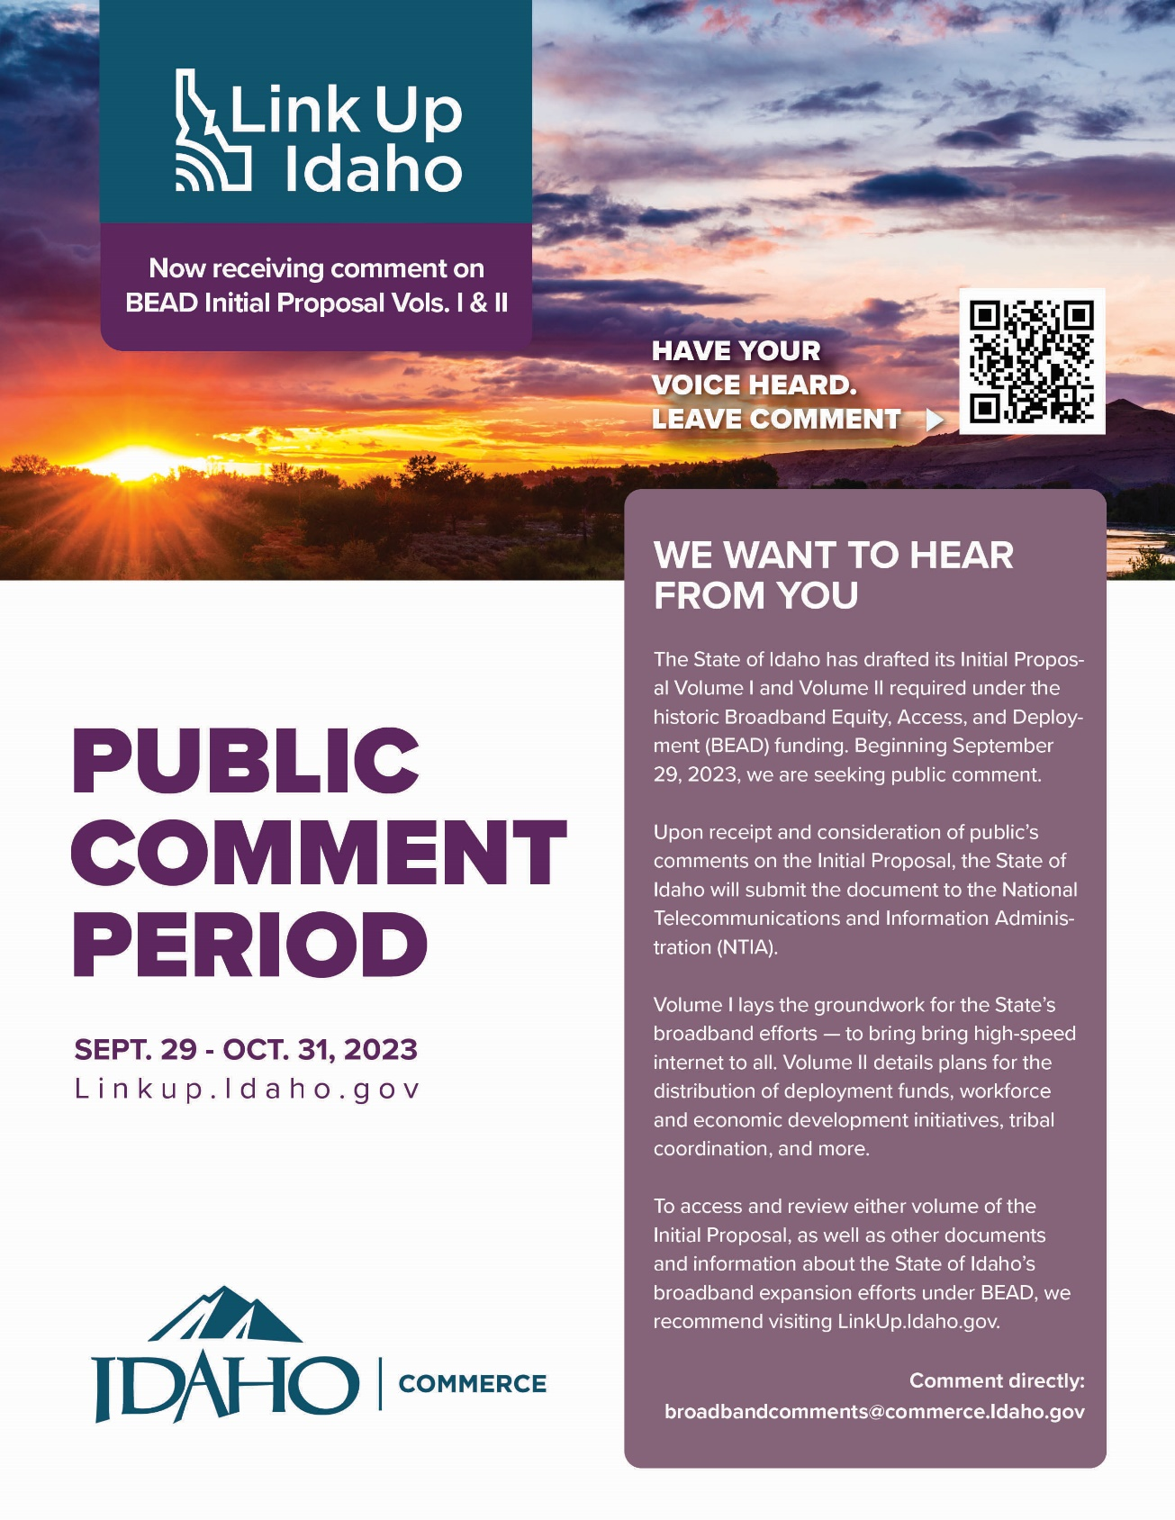

Radio Spot/Podcast/Audio Language

30-Seconds
The internet is a modern necessity like any other utility. Reliable internet access is necessary for children to achieve their education, residents to access healthcare, workers to find top-tier employment, businesses to expand operations, and families to stay connected.
But being unable to get online or stay online affects too many Idahoans.
That’s why the State of Idaho plans to ensure everyone can access reliable, affordable high-speed internet.
And the State wants to know your thoughts on its historic BEAD Initial Proposal Volumes I and II outlining and detailing the State’s plans for broadband expansion.
Visit LinkUp.Idaho.gov to read the plans and provide your feedback. You have from September 29 through October 31 to submit your comments.

