Idaho bead subgrantee

Request for information

guide
March 27, 2026

idaho department

of commerce



office of broadband

Overview
The Idaho Office of Broadband (IOB) looks forward to working with subgrantees on the next steps of the Broadband, Equity, Access, and Deployment (BEAD) funding as approved by the National Telecommunications and Information Administration (NTIA) and the National Institute of Standards and Technology (NIST). The IOB received NIST approval and issued its formal Amendment to its Notice of Award on January 26, 2026, triggering the six-month window to execute all Subgrantee Agreements.
This document provides subgrantees with a clear, comprehensive guide to the IOB’s Subgrantee Agreement Request for Information (RFI) process, covering the steps for successful submissions. Any updates will be announced through official channels and recorded in a change log to this document. Unless otherwise instructed and permitted, subgrantees must follow the instructions in this Guide and any subsequent updates or revisions.
The intended audience for this Guide is subgrantee representatives who will submit the RFI details and supporting documents. This material will inform project specific Subgrantee Agreements and provide the IOB with additional relevant supporting details. An officer or legal representative with binding authority must complete the agreement and sign the attestations and agreements for this RFI.
The IOB reserves the right to request more information from subgrantees as necessary to ensure all BEAD Program requirements and goals are met. Furthermore, the IOB reserves the right to request updated or additional information at any time to meet Idaho or NTIA documentation requirements.
Questions related to policy or procedural items should be directed to:
  - broadband@commerce.idaho.gov
Questions related to technical assistance with the Commerce Application Portal should be directed to:
  - grants@commerce.idaho.gov
Questions related to BEAD awards or the Subgrantee Agreement RFI should be directed to:
- IdahoBEAD@mbakerintl.com

Subgrantee Portal, Sections, Questions & Guidance
The Subgrantee Agreement RFI comprises a mix of questions and templates, all of which require information to support the development of the project-specific Subgrantee Agreements and the ongoing monitoring and compliance efforts for these awards. This information will be collected in the Idaho Broadband Salesforce portal as a centralized location for all required project data.
IMPORTANT!
Each project will have its own, distinct Subgrantee Agreement. For example, if you have four projects in the Idaho BEAD program, you will have four Subgrantee Agreements.
Before you begin, please complete the following steps:
- Access the Subgrantee Agreement Template Library:
The IOB has developed templates that require applicants to upload information or attestations into the Idaho Broadband Salesforce portal. These templates are available on the BEAD Awardees section of the Link Up Idaho website. The table below shows which templates are project-specific and which are company-specific. You must use the templates provided.
Download all available templates from the BEAD Awardees section of the Link Up Idaho website to your computer and rename each file with an identifier unique to your company, the project, and the subject matter of the template (e.g., Budget, Pro Forma, etc.). Be aware that Salesforce has a character limit on file names, so it is best to name files succinctly. These templates include:
Pro Forma Template | Template is project-specific
Project Budget Template | Template is project-specific
Permitting Milestone & EHP Template | Template is project-specific
Project Schedule (Construction Milestone) Template | Template is project-specific
Build America/Buy America Template | Template is project-specific
Cybersecurity and Supply Chain Risk Management Attestation | Template can be completed once
Protecting BEAD Program from Defaults Attestation | Template can be completed once
Byrd Anti-Lobbying Amendment Certification Lobbying Disclosure | Template can be completed once
Federal Funding Accountability and Transparency Act Disclosure Form | Template can be completed once
Lobbying Disclosure Form (Standard Form LLL (only if needed)) | Template can be completed once
- Provide Non-Template Documentation – The following documents will be needed to complete the Salesforce upload:
- An updated project-specific map with the network route and APA boundaries with BSL locations showing as points on the PDF map
- A Cybersecurity Risk Management Plan*
- A Supply Chain Risk Management Plan*
- Certificate of Insurance (in alignment with upcoming IOB guidance) *
- Letter of Credit or Performance Bond – Documentation for a Letter of Credit in the required amount is due prior to signing the Subgrantee Agreement, or a Performance Bond in the required amount is due within 60 days of signing the Subgrantee Agreement. These instruments must be project specific. For more information on Letter of Credit and Performance Bond obligations, please see additional guidance below.
*Can be completed once and uploaded

Using Salesforce
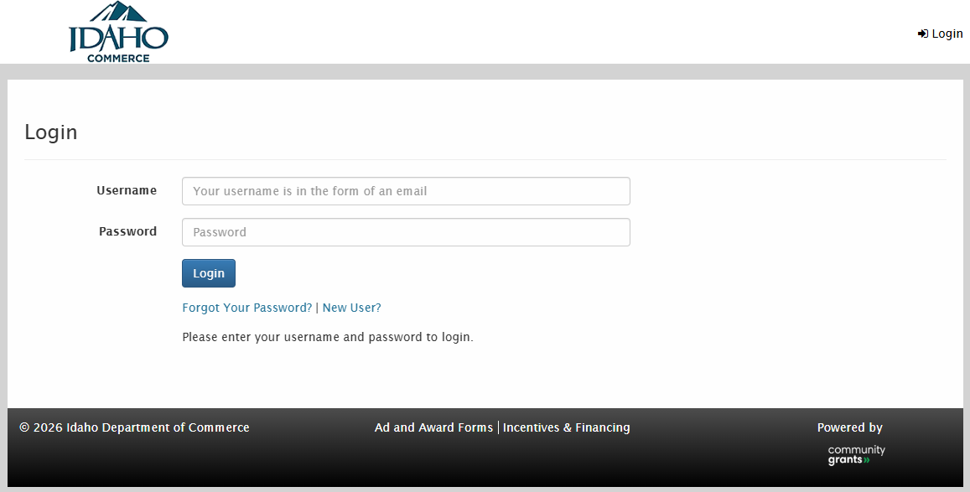
The IOB is using Salesforce to collect Subgrantee Agreement information. It is important to note that you will be required to respond to the company questions section once and submit one set of files per project. You may use your login credentials from the Prequalification and BEAD applications to access the portal. Please note that your company has one set of credentials. The Salesforce login page can be found here.

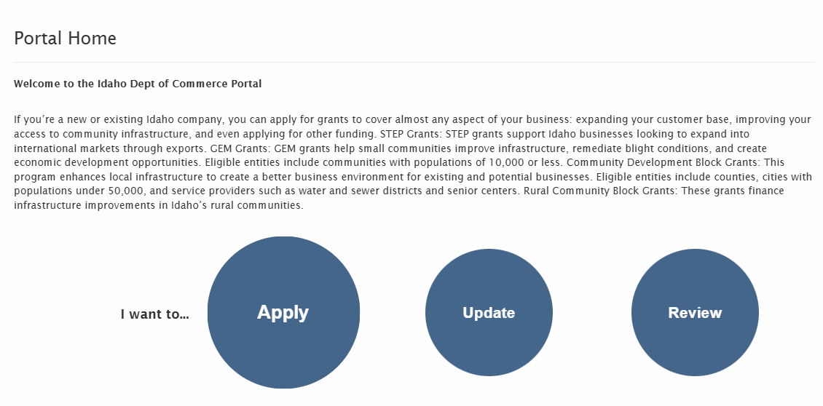
Once in the portal, you will see the Portal Home screen with three options. Please select “Apply.”

There are two portals to which you must respond. The Company Specific Questions portal contains the Subgrantee Portal questions that come first in the guide, and the Project Specific Questions portal includes the BEAD Project Portal questions outlined later in this document.


The Idaho Department of Commerce uses Salesforce for a variety of grant activities. You will notice references to “Apply” and “Funding Opportunity.” Please be assured that this is standardized language and that the two portals you’ll be using are for this BEAD RFI. For example, in both portals, you will see an “Apply Now” button, and the next page is an “Overview” page that asks for the requested amount and the proposed project name.

The fields on the Overview page will not contribute to the RFI and are part of every portal developed by the Department of Commerce.
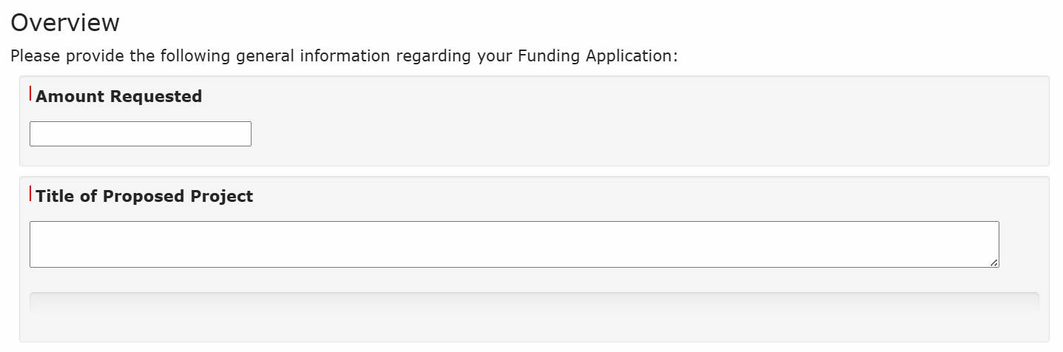
For the “Amount Requested,” you can enter 0.00. For the “Title of Proposed Project,” enter N/A. Responses to this Overview section will not affect your BEAD grant award.

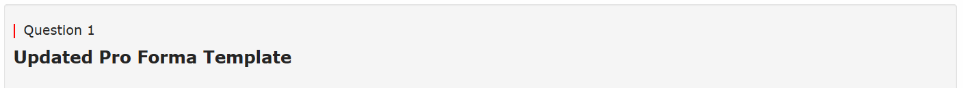
Whenever you see a red line next to the question number, a response is required. You will see the red line next to most questions, and you will not be able to submit the “application” without responding.

The following section outlines the Salesforce flow, including the questions, required uploads, and guidance for responding to each question.
RFI Questions & Details

Subgrantee Portal
The Subgrantee Portal contains company-specific questions. After logging in to Salesforce, you will look for the link to RFI BEAD Subgrantee: Company Specific Questions.
At the beginning of the portal, after selecting the portal link, an informational page will appear, prompting you to “Apply for this opportunity.” You will then come to a page with a picklist where you can select your company, then click “Apply now.” Please note that it is important to select the company name from this dropdown.
The first section of the portal is a system-required “Overview” page. For the “Amount Requested,” you can enter 0.00. For the “Title of Proposed Project,” enter N/A. You do not need to enter project details in these two fields. After completing these fields and selecting “Next,” the Subgrantee Contact Information questions will appear.

Subgrantee Contact Information
The IOB is collecting this information to ensure that the most current details are recorded and used for activities such as preparing the Subgrantee Agreement, communicating with subgrantees, collecting quarterly reporting, and processing reimbursement requests.
- Enter the Subgrantee Legal Business Name and Doing Business As (DBA)
  - This entry has been prepopulated and must match the name associated with the UEI number.
  - If you disagree with the information presented, please email grants@commerce.idaho.gov with a description of your issue.
- Certify the Legal Business Name and DBA, if applicable, are correct
  - Select Yes or No
- If the Legal Business Name and DBA, if applicable, are NOT correct, enter the correct Legal Business Name and DBA. If it is correct, please enter N/A.
  - Enter the correct Legal Business Name and DBA in the text box if it is incorrect.
  - If it is correct, please enter N/A.
- Subgrantee Website
  - Identify the company’s full website in the text field.
- Subgrantee’s Full Address
  - Please enter the company’s mailing address that will be used for this BEAD project.
- Primary Point of Contact Name
  - Enter the first and last name of the individual who will be the primary contact for BEAD communications.
- Primary Point of Contact Title
  - Include the title of the primary contact.
- Primary Point of Contact Phone Number
  - Add the direct phone number of the primary contact using the xxx-xxx-xxxx format. This should be the phone number the contact uses most frequently.
- Primary Point of Contact Email Address
  - Add the direct email address for the primary contact. Do not include a generic company email address.
- Secondary Point of Contact Name
  - Enter the first and last name of the individual who will be the secondary/backup contact for BEAD communications.
- Secondary Point of Contact Title
  - Include the title of the secondary contact.
- Secondary Point of Contact Phone Number
  - Add the direct phone number of the secondary contact using the xxx-xxx-xxxx format. This should be the phone number the contact uses most frequently.
- Secondary Point of Contact Email Address
  - Add the direct email address for the secondary contact. Do not include a generic company email address.
- FCC Registration Number (FRN)
  - This has been prepopulated.
- Certify the FRN is correct
  - Select Yes or No.
- If the FRN is NOT correct, enter the correct number. If it is correct, enter N/A.
  - If the FRN presented is incorrect, insert the correct 10-digit number.
  - If the FRN presented is correct, enter N/A.
- IRS Employer Identification Number (EIN)
  - This has been prepopulated.
- Certify the EIN is correct
  - Select Yes or No.
- If the EIN is NOT correct, enter the correct number. If it is correct, enter N/A.
  - If the EIN presented is incorrect, enter the company’s nine-digit EIN using the xx-xxxxxxx format.
  - If the number presented is correct, enter N/A.
- Unique Entity ID (UEI) number
  - This has been prepopulated.
- Certify the UEI is correct
  - Select Yes or No.
- If the UEI is NOT correct, enter the correct number. If it is correct, enter N/A.
  - If the number presented is incorrect, enter the 12-character alphanumeric identifier assigned by SAM.gov (i.e., XXXXXXXXXXXX)
  - If the number presented is correct, enter N/A.
- UEI Expiration Date
  - Add the SAM.gov registration expiration date as xx-xx-xxxx.
- Idaho State Tax Identification Number
  - Insert the nine-digit account/permit number issued by the Idaho State Tax Commission

Other Subgrantee & Project Information
This section requires you to upload several files. Please be aware that Salesforce has a character limit on file names, so it is best to keep them succinct; otherwise, they won’t upload.
- Cybersecurity and Supply Chain Risk Management Attestation
  - Download the Cybersecurity and Supply Chain Risk Management Attestation from the Link Up Idaho website.
  - This attestation will be Attachment 6 in the Subgrantee Agreement and needs to be signed by an authorized company representative.
  - In addition to including Entity Name, Address, and Date, this attestation has a field for the Signature, including the individual’s Title and the Entity Name.
  - Upload the signed document to Salesforce.
- Cybersecurity Risk Management Plan
  - Upload your Cybersecurity Risk Management Plan to Salesforce.
  - NTIA requires subgrantees to have a cybersecurity risk management plan that incorporates the latest NIST guidelines.
- Supply Chain Risk Management Plan
  - Upload your Supply Chain Risk Management Plan into Salesforce.
  - NTIA requires subgrantees to have a supply chain risk management plan that incorporates the latest NIST guidelines.

- Protecting the BEAD Program from Defaults Attestation
  - Download the Protecting the BEAD Program from Defaults Attestation template from the Link Up Idaho website.
  - This attestation will be Attachment 7 in the Subgrantee Agreement and needs to be signed by an authorized company representative.
  - In addition to including Entity Name, Address, and Date, this attestation has a field for the Signature, including the individual’s Title and the Entity Name.
  - Upload the signed document to Salesforce.
- Byrd Anti-Lobbying Amendment Certification
  - Download the Byrd Anti-Lobbying Amendment Certification template from the Link Up Idaho website.
  - This certification will be Attachment 11 in the Subgrantee Agreement and needs to be signed by an authorized company representative.
  - In addition to including Entity Name, Address, and Date, this attestation has a field for the Signature, including the individual’s Title and the Entity Name.
  - Upload the signed document into Salesforce.
- Lobbying Disclosure Form (Standard Form LLL)
  - Download the Lobbying Disclosure Form from the Link Up Idaho website.
  - This form should only be submitted when a subgrantee has a qualifying lobbying activity to disclose pursuant to federal law.
    - Pursuant to 31 U.S. C. 1352, the lobbying disclosure form shall be completed by the reporting entity, whether the Subgrantee or prime Federal recipient, at the initiation or receipt of a covered Federal action, or a material change to a previous filing. The filing of a form is required for each payment or agreement to make payment to any lobbying entity for influencing or attempting to influence an officer or employee of any agency, a Member of Congress, an officer or employee of Congress, or an employee of a Member of Congress in connection with a covered Federal action.
  - If you have qualifying lobbying events to disclose, complete all items of the fillable PDF that apply to both the initial filing and the material change report.
  - Upload the completed PDF form to Salesforce, if applicable.

- Federal Funding Accountability and Transparency Act (FFATA) Disclosure Form
  - Download the FFATA Disclosure Form from the Link Up Idaho website.
  - All subgrantees must complete the basic identifying information requested in the fillable PDF form.
  - Only subgrantees that meet the stated qualifications in the form must complete the “Compensation of Officers” section of this form.
  - Upload the completed PDF form to Salesforce.
- Certificate of Insurance
  - Upload the company’s certificate of insurance that will demonstrate coverage for the awarded projects.
  - Additional guidance will be issued regarding the specific insurance coverage requirements.
  - Subgrantees must submit this information prior to signing the Subgrantee Agreement.

Certification
- Type your name, title, and date below, you are electronically signing your submission
  - Enter these details, indicating that you understand and accept all the terms and conditions stated within the application, and declare that the information provided is true and that the documents you are submitting in support of your application are genuine and have not been altered in any way.
- I acknowledge that any actual, potential, or perceived conflict of interest, including partnerships or involvement of staff/board members in project services, must be fully disclosed and reported to Idaho Commerce immediately.
  - Confirm that you are aware of, and will comply with, the obligation to disclose any conflict of interest to the Idaho Department of Commerce by marking “yes” in the portal.
- If you have any conflicts of interest, please describe any actual, potential, or perceived conflicts in the text box below. If not applicable, please enter N/A.
  - If you are currently aware of any conflict of interest that your company may have, please use the field in #35 to describe the conflict of interest.
  - It is an ongoing obligation for your company to report any current or future conflict of interest as soon as the company becomes aware of the conflict.

Review & Status
This is a review page that provides an overview of questions that were answered, not answered but required, and those that are optional. You must respond to all required questions. To fix errors, use the “Previous” and “Next” buttons to navigate through the sections. Once all the required questions have been answered, select “Submit Funding Application.”

BEAD Project Portal
The BEAD Project Portal contains the project-specific questions. After logging in to Salesforce, you will look for the link to RFI BEAD Subgrantee: Project Specific Questions.
At the beginning of the portal, an informational page will appear, prompting you to “Apply for this opportunity.” You will then come to a page with a picklist with project IDs. Use the dropdown to identify the Project ID that was included in the Project Fact Sheet attached to the IOB BEAD Subgrantee Notice of Award email sent on Monday, March 9. The format will be CM61-BEAD-ID-XXXXXX. Please select any one of your awarded projects from the drop-down list, and then click “Apply Now.” Please note that it is important to select a Project ID from the dropdown list.
Note that you will answer this set of questions for each project to ensure that every Subgrantee Agreement accurately reflects the unique scope, geography, cost structure, and technical details of that project.
The first section of the portal is a system-required “Overview” page. For the “Amount Requested,” you can enter 0.00. For the “Title of Proposed Project,” enter N/A. You do not need to enter project details in these two fields. Responses to this Overview section will not affect your BEAD grant award. After completing these fields and selecting “Next,” the Subgrantee Contact Information questions will appear.

Project Information
This section requires you to upload several files. Please be aware that Salesforce has a cap on the number of characters in a file name, so it is best to keep your file names succinct; otherwise, they won’t upload.
- Updated Pro Forma Template
  - Download the new Pro Forma Template from the Link Up Idaho website.
  - Please use this template to submit a new Pro Forma that reflects the project as approved by NTIA and NIST, providing any new or updated financial projections and project details.
  - You are required to complete one template per project, using the most current and accurate information available.
  - This template will not be included as an attachment to the Subgrantee Agreement but will be used for ongoing reporting.
  - The blue box, which is cell B4, is a dropdown list for you to select the Project ID associated with this Pro Forma.
    - The Applicant Name in cell B5 will automatically populate.
  - The green B6 and B7 cells are for the Estimated Project Construction Start Date and the Estimated Project Construction End Date. Please use the XX/XX/XXXX format.
  - The template asks you to forecast subcategories related to Revenue, Operating Expenses, EBITDA, Cash Flow Statement, Financing, and Key Metrics, including the Construction Phase for years 1 – 4, and Operating Phase for years 5 – 14.
    - Use negative values for any expenses or expenditures.
    - The grey cells are auto summed and cannot be manually adjusted.
  - Upload the completed template to Salesforce.
- Updated Project Budget Template
  - Download the Project Budget Template from the Link Up Idaho website.
  - This template will be Attachment 3 in the Subgrantee Agreement.
  - The Project Budget Template gathers project-specific costs for Pre-award and Years 1 – 4 in the following categories, some of which have specific sub-categories identified in the template:
    - Professional services
    - Construction services
    - Outside Plant, Towers, and Poles
    - Network Access Equipment
    - Operating Equipment
    - Customer Premise Equipment (LEO only)
    - Contingency Funds
    - Other Allowable Costs
- The following instructions will help you complete the template. Please note that the template also includes instructions.
    - You are required to complete one template per project, using the most current, accurate information available.
    - The blue box, which is cell B4, is a dropdown list for you to select the Project ID associated with this budget.
      - Once selected, cells C5, C6, C7, and C8 will auto-populate with the NTIA-approved project award information, including the allocated BEAD Funding, Subgrantee Match, Other Match, and Total Project Cost dollars. These fields should be reviewed for understanding and acknowledgement.
      - The green cells in rows 14 – 38 should be filled out with the expected dollar amount for each cost category, entering $0 for fields that are not applicable to the project. Please note that the grey cells in column I will populate with the subtotals and totals for each row.
    - The sum of all cost categories (cell I41) should equal the amount inclusive of Federal BEAD Funding and Subgrantee Match dollars (i.e., the Total Project Cost).
  - Upload the completed template to Salesforce.
- Letter of Credit or Performance Bond
  - Upload the Letter of Credit or Performance Bond documentation for the project(s).
  - Note:
    - This is not due at the same time as the rest of the RFI materials.
    - IOB will send additional guidance with a specific due date for this material but note that a letter of credit in the required amount for each project must be submitted prior to signing the Subgrantee Agreement, or a performance bond in the required amount must be submitted within 60 days of signing the Subgrantee Agreement.
    - Subgrantees that submit a letter of credit must include an opinion letter from legal counsel regarding treatment of the letter of credit in bankruptcy proceedings. The letter must state that in a proceeding under the Bankruptcy Code, the court would not treat the letter of credit as property of the winning subgrantee’s bankruptcy estate. This requirement does not apply to subgrantees submitting a performance bond.
    - If a BEAD subgrantee has more than one BEAD project within an Eligible Entity, they must submit a letter of credit or performance bond for each project, and it should specify the project number and the value assigned to each project.
- For more guidance, please see NTIA Guidance documentation, including the NTIA Policy Notice (October 2023), and consult the NTIA FAQ here, NTIA FAQ Version 19.
  - Upload the file to Salesforce once available, but not later than the date required by IOB.
- Updated Map showing network route and APA boundaries with BSL locations showing as points on the map
  - The file must be a PDF.
  - This map will be included as part of Attachment 1 to the Subgrantee Agreement.
  - Note that awarded APAs are listed in the fact sheets sent via email on March 9th, 2026. You can also download APAs as spatial data via ArcGIS Online.
  - In addition to the network route, APA boundaries, and BSL locations, include the following elements, when applicable:
    - Fiber and/or coaxial routes, making distinctions between new and existing.
    - Placement of new and existing towers, making distinctions between new and existing, and modeled coverage area.
    - Placement of new and existing satellite ground equipment or stations, making a distinction between new and existing, and the area to be served by each station.
    - Existing backhaul and middle-mile routes that will be relied upon for the project, designating each technology (fiber, microwave, etc.).
    - Planned backhaul and middle-mile routes that will be constructed as part of the project, designating the technology for each.
    - Planned open access routes that will be constructed as part of the project, designating the technology for each.
    - Planned locations where the applicant must obtain right-of-way permission or easement access.
    - Location of the interconnection points and the planned conduit access points. (must be placed at regular intervals).
    - Location of key elements such as outside plant placement of terminals and hubs, points of presence, huts, and central offices.
    - Upload the map to Salesforce.

- Identify the maximum Download Speeds that will be offered at the Completion of the Period of Performance in Mbps.
  - This field only permits up to five numbers. You will not be able to include Mbps.
    - If the download speed will be 1 Gbps, enter 1000.
- Identify the maximum Upload Speeds that will be offered at the Completion of the Period of Performance in Mbps.
  - This field only permits up to five numbers. You will not be able to include Mbps.
    - If the upload speed will be 1 Gbps, enter 1000.
- Identify the amount of Fiber Miles to be placed, if applicable.
  - If the project involves fiber, insert the anticipated miles of fiber that will be placed by project completion.
  - If the project does not include placement of new fiber, enter N/A.
- Identify the number of New Towers that will be placed, if applicable.
  - If New Towers will be placed, insert the total number here.
  - If the project does not include the construction of New Towers, enter N/A.
- Identify the number of Existing Towers being used, if applicable.
  - If equipment will be placed on Existing Towers, insert the total number here.
  - If the project does not include placement of equipment on Existing Towers, enter N/A.
- Please include a Project Summary/Description that reflects the approved project.
  - In approximately 150 or fewer words, describe the BEAD-funded project, including details such as the area(s) that will be served, the speeds that will be available, the Application Project Area (APA) numbers, total locations that will be served, and the technology that will be offered.
- Describe your Low-Cost Plan terms, including pricing and speeds.
  - Use this field to describe the terms of the Low-Cost Service Offering(s) that will be available to eligible customers over the funded network.
  - At a minimum, include a description of the speeds of the service offering, recurring and non-recurring pricing, any included equipment or devices, and eligibility qualifications.

- Subcontractor Information Details, respond with N/A if not applicable. Include ALL subcontractor’s company names, mailing address, and phone numbers.
  - If applicable and known, you are asked to include the business name(s), address(es), phone number(s), and email address(es) for the subcontractor(s) you plan to engage for this project.
  - If the information is not yet known, please enter TBD.
  - If this is not applicable and you will not be using subcontractors, enter N/A.
- Subcontractor Scope of Work. If utilizing multiple subcontractors, explain each of their scopes.
  - If applicable and known, insert a brief description or list of activities for which the subcontractor(s) identified in the prior question will be responsible.
  - If the information is not yet known, please enter TBD.
  - If this is not applicable and you will not be using subcontractors, enter N/A.
- Permitting Milestone & EHP Milestone Template
  - Download this Permitting Milestone & EHP Template from the Link Up Idaho website.
  - This template is required by NTIA to track the progress of each project, but will not be an attachment to the Subgrantee Agreement
  - Use this template to provide key milestone dates for each element of the required environmental and historic preservation review processes under federal and state law for the funded project.
  - Also use this template to provide key milestone dates for each federal access permit that will be required to gain access to federally controlled land for the funded project, including right-of-way, easements, traffic control, or other required approvals
  - This template has a few informational resources included under Additional Notes in rows 43 – 45, including:
    - NTIA’s Smart Start Part II: How to Approach and Implement BEAD Subgrant Permitting Conditions
      - https://broadbandusa.ntia.gov/technical-assistance/Smart_Start_II_BEAD_Subgrant_Permitting_Conditions.
    - NTIA Memo: Authorization of NTIA Grant Recipients to Initiate Section 106 Consultation for NTIA Funded Projects
      - https://broadbandusa.ntia.gov/sites/default/files/2025-10/NTIA_Section_106_NHPA_Grant_Recipient_Delegation_Notice.pdf
    - NHPA Consultation Process Fact Sheet
      - https://broadbandusa.ntia.gov/sites/default/files/2025-12/EHP_NHPA_Sect_106_Consultation_Process_Fact_Sheet_12_25.pdf
    - NTIA/USFWS Guidance for Streamlined ESA Compliance
      - https://broadbandusa.ntia.gov/sites/default/files/2026-03/NTIA_Guide_to_Streamlined_ESA_Compliance_for_Broadband_Deployments_03_26.pdf
    - The NTIA/USFWS Memo on Authorization of NTIA Grant Recipients to Serve as Non-Federal Representatives for Section 7 Consultation
      - https://broadbandusa.ntia.gov/sites/default/files/2025-08/NTIA_FWS_Non-Federal_Designation_Memo_2025.pdf
  - This template gathers information applicable to your project, including:
    - An overall EHP compliance timeline in row 5 for federal requirements, and more specific breakdowns for the following:
      - Section 106 National Historic Preservation Act Compliance in rows 7 – 11
      - Clean Water Act, Section 401, 404, and/or 408, Compliance in rows 13 – 16, with the option to add lines as needed
      - Endangered Species Act Compliance in rows 18 – 22
    - Other NEPA and Environmental Review in rows 24 – 26, with the option to add lines as needed
    - State and Local Environmental and Historic Preservation Compliance, with the option to add lines as needed
    - Federal Agency Permits/Authorizations/Consents in rows 32 – 39
      - This template only requires information about permits that will be required from federal agencies for access or other compliance purposes.
      - Additional information about state and local permits will be collected after the Subgrantee Agreement is signed.
  - The template requires you to add expected dates, as applicable, for the following:
    - To Begin Review Process or Submit Application to Authorizing Agency in column C
    - To Complete Review Process or Finalize Documentation for Authorizing Agency (or Expected Date for Other Specified Event) in column D
    - Of Approval or Permit Issuance by Authorizing Agency; Submission to IOB in column E
  - Each section identifies a row for “rollup,” which should be the overall timeline for each section
  - Upload the completed template to Salesforce.
- Project Schedule (Construction Milestone) Template
  - Download the Project Schedule (Construction Milestone) Template from the Link Up Idaho website.
  - The information included in this template will be used by the IOB to monitor progress throughout the project, including at the execution of the Subgrantee Agreement and during quarterly reporting.
    - A copy of the template will be included in your Subgrantee Agreement to document the milestones, establish consistent expectations and terminology, and provide a baseline reference for milestones.
    - The version used for quarterly reporting will have additional columns and lines for specific details and updates, including:
      - Identifying the status of each milestone.
      - Entering dates when reached or anticipated.
      - Providing explanations for delays or changes.
      - Uploading supporting documentation.
  - This template will be Attachment 2 of the Subgrantee Agreement.
  - The template identifies project phases and milestones and provides fields for you to include a description, forecasted start date, and forecasted completion date.
    - The phases include Pre-construction, Construction, and Testing.
    - The milestones include Design and Engineering, Permitting and Pole Attachment Agreements, EHP Assessments, Materials Delivered, Construction, Make-ready Complete, Underground Construction, Aerial Construction Complete, Tower(s) Built, Electronics Installed, Testing and Turn-up.
      - Only details that are applicable to your project have to be included.
  - One template per project is required, using the most current, accurate information available.
  - The following instructions will help you complete the template. Please note that the template also includes instructions.
    - You are required to complete one template per project.
    - The blue box, which is cell A3, is a dropdown list for you to select the Project ID associated with this budget.
    - Use column C to insert descriptions for each milestone as they pertain to the project.
      - The Example Entries tab of the template includes samples as a reference.
    - Add the Forecasted Start Date for each milestone in column D.
    - Add the Forecasted Completion Date for each milestone in column E.
  - Upload the completed template to Salesforce.
- Build America/Buy America Template
  - Download the NTIA BABA Template from the Link Up Idaho website.
  - This template is required by NTIA but will not be an attachment to the Subgrantee Agreement.
  - The IOB will be required to report on subgrantee BABA compliance to NTIA on a semi-annual basis.
    - For more information about the NTIA BABA requirements, please reference the NTIA BroadbandUSA website and the BABA Compliance and Self Certification page here, https://broadbandusa.ntia.gov/technical-assistance/BABA_Compliance_and_Self_Certification.
    - You can also reference these additional materials: NTIA BEAD BABA Refresher: Build America Buy America (BABA) Act Refresher and Department of Commerce BEAD BABA FAQ: CLEAN FINAL BEAD BABA FAQ_2.21.24.pdf.
  - One template per project is required.
  - This template is used to identify finished waived electronics that will be used for the project, including identifying:
    - The manufacturer of the product
    - The category of electronics.
    - The 10-digit Harmonized Tariff Schedule (HS) code.
    - The product identification.
    - A description of the product function.
    - The country of origin.
    - The quantity of the product.
    - Complete this template with as much information as currently exists regarding planned equipment for the project, including equipment that is not BEAD-grant funded or will be supplied with matching funds; subgrantees will update this template as necessary during the period of performance with their quarterly reports.
    - Upload the completed template to Salesforce.

Certification
- Type your name, title, and date below, you are electronically signing your submission
  - Enter these details, indicating that you understand and accept all the terms and conditions stated within the application, and declare that the information provided is true and that the documents you are submitting in support of your application are genuine and have not been altered in any way.

Review & Status
This is a review page that provides an overview of questions that were answered, not answered but required, and those that are optional. You must respond to all required questions. To fix errors, use the “Previous” and “Next” buttons to navigate through the sections. Once all the required questions have been answered, select “Submit Funding Application.”

